National Arts in Nursing Homes Day (May 26th 2023)
Award 2023
  - Deadline: 5pm, Friday February 24th 2023
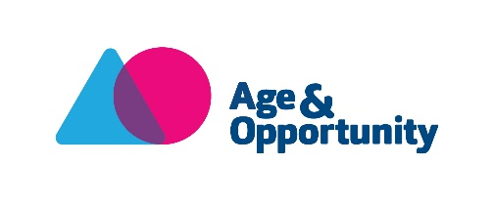

Application Form

Please read the award guidelines before completing the following application form. The final application form, along with the artist’s CV and 3 examples of their work should be emailed to arts@ageandopportunity.ie no later than 5pm, Friday February 24th 2023.
Name and address of applicant:
Phone number:
Email:
Why do you want this award? (100 words)
Please describe your proposed project/initiative/event (350 words)
Please describe how a) your project leading up to the event (i.e. workshops or other initiatives) and b) any final celebratory event will focus on and engage with residents (150 words)
Please describe the history of arts projects/initiatives/events in this care setting OR your experience of facilitating as an artist (max 150 words)
Please name the artist involved in/leading the project and include a short bio (150 words). Please refer to the guidelines for definitions of a professional artist and note that this cannot be the care setting’s activity coordinator). Note we have also asked you to supply an artist’s CV and three examples of work.
Please outline your timeline for the proposed project/initiative/event (50 words)
Please complete the budget template below for your proposed project/event/initiative including financial contribution from the care setting or in-kind support. Please indicate whether you are applying for the larger award of €1000 or the smaller award of €500
Award amount: □ €1000 □ €500

Income: (for example: award amount, financial contribution from nursing home, in-kind support, etc.)

Expenditure: (for example: artist fee, materials, photographer fee, etc.)

